To: New Jersey Law Revision Commission
From: Samuel M. Silver
Re: Commencement of Statute of Limitations for Personal Injury Protection Benefits pursuant to N.J.S. 39:6A-9.1
Date: January 07, 2019

M E M O R A N D U M
Executive Summary
An insurer that has provided personal injury protection (“PIP”) benefits must bring suit seeking reimbursement from a tortfeasor before the conclusion of the two-year statute of limitation or lose the ability to bring such an action. The two-year period begins upon “the filing of a claim” for such benefits. A question regarding the commencement of the statute of limitations arises, however, upon the filing of multiple PIP applications.
In Abdulai v. Casabona et al. the Appellate Division was asked to determine the date that a PIP claim was “filed” because both the insured and his health care provider each submitted a PIP application on separate dates and used separate forms for their submissions. The Court recognized that the language in N.J.S. 39:6A-9.1(a) is ambiguous regarding the date on which a PIP claim is deemed to be “filed” for purposes of calculating the statute of limitations.
Statute
N.J.S. 39:6A-9.1(a) Recovery of personal injury protection benefits from tortfeasor
a. An insurer, health maintenance organization or governmental agency paying benefits pursuant to subsection a., b. or d. of section 13 of P.L.1983, c. 362 (C.39:6A-4.3), personal injury protection benefits in accordance with section 4 or section 10 of P.L.1972, c. 70 (C.39:6A-4 or 39:6A-10), medical expense benefits pursuant to section 4 of P.L.1998, c. 21 (C.39:6A-3.1) or benefits pursuant to section 45 of P.L.2003, c. 89 (C.39:6A-3.3), as a result of an accident occurring within this State, shall, within two years of the filing of the claim, have the right to recover the amount of payments from any tortfeasor who was not, at the time of the accident, required to maintain personal injury protection or medical expense benefits coverage, other than for pedestrians, under the laws of this State, including personal injury protection coverage required to be provided in accordance with section 18 of P.L.1985, c. 520 (C.17:28-1.4), or although required did not maintain personal injury protection or medical expense benefits coverage at the time of the accident.
Background
On June 26, 2011, a vehicle owned by Budget Truck Rental, LLC (“Budget”) allegedly struck the rear of the automobile that was being driven by Agim and Rufije Abdulai (collectively, the “Abdulais”). On June 27, 2011, the Abdulais’ injuries were reported to their insurance carrier, Mercury Indemnity Company of America (“Mercury”). On June 29, 2011, Mercury’s insurance adjuster mailed a PIP application (the “Mercury application”) to the Abdulai’s attorney and requested that it be completed and returned to the insurance company.
In July 11, 2011, Mercury received a “generic” PIP application, signed by the Abdulias, from their treating provider. On July 22, 2011, Mercury placed the tortfeasor’s insurance company, Acadia Insurance Company (“Acadia”), on notice of its intention to seek reimbursement for PIP benefits paid on behalf of the Abdulias. On August 3, 2011, the Abdulais’ completed Mercury’s PIP application. This PIP application was received by Mercury on August 15, 2011.
Mercury filed a complaint against Acadia, and others, seeking reimbursement of PIP benefits that it paid on behalf of the Abdulais’. The date that this complaint was filed, August 2, 2013, formed the basis of the underlying dispute between the parties. On January 31, 2014, Acadia filed summary judgment motion alleging that Mercury’s complaint for PIP reimbursement was filed outside the two-year statute of limitations proscribed by N.J.S. 39:61-9.1. Acadia argued that Mercury’s July 11, 2011, receipt of the generic PIP application triggered the statute of limitations set forth in N.J.S. 39:61-9.1(a) and that Mercury’s complaint was not filed within the time-frame set forth in the statute.
On February 28, 2014, the trial court denied Acadia’s motion for summary judgment. The trial court held that “the claim” was deemed “filed” when it is submitted by the insured in the form requested by the insured rather than the submission of a generic form submitted by a health care provider. Acadia appealed from this decision.,.
Analysis
In Abdulai v. Casabona et al. the Appellate Division was asked to determine when a claim was deemed “filed” for purposes of initiating the statute of limitations set forth in N.J.S. 39:6A-9.1(a). As a preliminary matter, the Court observed that the statute “does not provide a definition for the date that triggers the ‘filing of a claim.’” The Court further recognized that the language contained in N.J.S. 39:6A-9.1(a) is ambiguous concerning when a PIP claim is deemed to be “filed” for purposes of calculating the statute of limitations. In the absence of any statutory guidance on the subject, the Court examined the case law regarding the statute to fashion its opinion.
In New Jersey Mfr. Ins. Grp. v. Holger Trucking Corp. the Appellate Division was asked to interpret the meaning of “the claim” in the context of N.J.S. 39:6A-9.1. The question to be answered by the court was “whether the claim is filed when an insured or health care provider first requests reimbursement for PIP benefits or when the insured submits a claim form requested by the insurer.” The Court concluded that, “it is the submission of the PIP claim form that triggers the two-year statute of limitations period contained in N.J.S.A. 39:6A-9.1....” The Court then turned its attention to determining whether the PIP claim is deemed “filed” when a generic form of PIP application is submitted to the insurer by a health care provider.
In Abdulai v. Casabona the Court recognized that there were significant distinctions between the generic PIP application provided by the third-parties and the application provided to the insured the surety. Among the differences are: the presence of HIPPA authorizations that enable the surety to obtain additional treatment records critical in determining causality of injuries and treatment; the request for added detail regarding all household vehicles, insurance policies and family physician information.”
Relying on its decision in Holger, the Appellate Division concluded that a “claim” is “filed” when an insured’s submission of a PIP application in the form requested by the insurer is received by the insurer. This decision was predicated on the fundamental belief that “an insurer should be entitled to rely on information it deems accurate and necessary for the proper processing of an application for PIP Benefits.” The court went on to hold that, “this information should be submitted in the form of a single document requested by the insured.” To protect tortfeasors from dilatory conduct by errant insurance companies, such as allowing a claim to languish, the court signaled that unreasonable delays in the processing of such paperwork may result in running of the statute of limitations.
Conclusion
Staff seeks authorization to conduct additional research and outreach regarding this issue in order to determine whether modifying the language of N.J.S.A. 39:6A-9.1(a) to provide that it is an insured’s submission of a PIP application in the form requested by the insurer that triggers the statute of limitations and that such submissions should be submitted without an unreasonable delay.

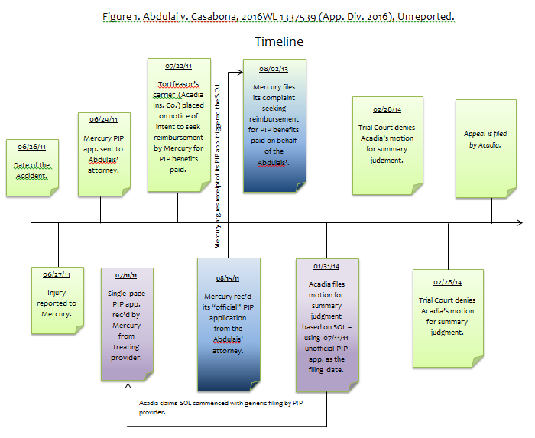

N.J.S. 39:6A-9.1.
Id.
2016 WL 1334539 (App. Div. 2016).
Id.
Id. at *1.
Id.
Id.
Id.
Id.
Id.
Id.
Id.
Id. at 2.
Id.
Id.
Id.
Id.
Id.
See Figure 1.
2016 WL 1334539 (App. Div. 2016).
Id. at *3.
Id.
417 N.J. Super. 393, 396 (App. Div. 2011).
Abdulai v. Casabona 2016 WL 1334539 *1 (App. Div. 2016), citing New Jersey Mfr. Ins. Grp. v. Holger Trucking Corp. 417 N.J. Super. 393, 394-95 (App. Div. 2011).
Id. at *3 (emphasis added).
Id.
Id. at *4.
Id.
Id.
Id.
Id.
Id.

