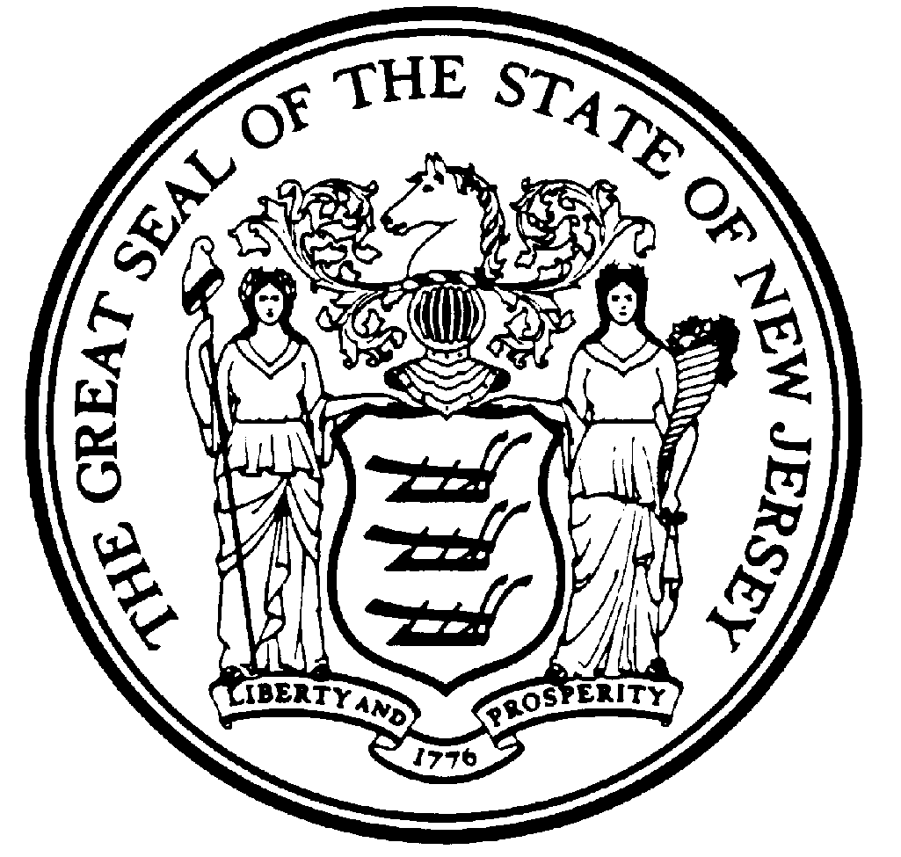

NEW JERSEY LAW REVISION COMMISSION

Final Report
Relating to Misconduct and the
Unemployment Compensation Act

June 20, 2019

The work of the New Jersey Law Revision Commission is only a recommendation until enacted.

Please consult the New Jersey statutes in order to determine the law of the State.

Please send comments concerning this Report or direct any related inquiries, to:

Jennifer Weitz, Counsel
New Jersey Law Revision Commission
153 Halsey Street, 7th fl.
Newark, New Jersey 07102
973-648-4575
(Fax) 973-648-3123
Email: jdw@njlrc.org
Web site: http://www.njlrc.org

Introduction

In July 2018 the Law Revision Commission authorized a project on employee misconduct and unemployment benefits as a result of the ruling in In re N.J.A.C. 12:17-2.1, 450 N.J. Super. 152 (App. Div. 2017). The Appellate Division invalidated the regulation, adopted in 2015 by the Department of Labor and Workforce Development, for being arbitrary and capricious, as its definition of “simple misconduct” included behavior that was more severe than “severe misconduct,” and because the regulation mixed concepts of negligence with those of intent.

Background
New Jersey’s Unemployment Compensation Law, N.J.S. 43:21-1 et. seq., enacted in 1936, seeks to counter the “menace” of “economic insecurity due to unemployment.” Among the disqualifying events listed in N.J.S. 43:21-5, Disqualification for benefits, is “misconduct.” The statute subdivides this category into “misconduct” and “gross misconduct.” However, only gross misconduct is defined, as “an act punishable as a crime of the first, second, third or fourth degree.”

Courts have attempted to provide a definition for simple misconduct. Through various holdings, misconduct has been construed as “deliberate and willful disregard of standards of conduct an employer has a right to expect.” In Silver v. Board of Review, the Appellate Division traced the history of the Unemployment Compensation Law and emphasized “[t]he critical distinction between intentional and deliberate conduct on the one hand and negligent or inadvertent conduct on the other[.]” Additional cases have reiterated that misconduct must involve “deliberate or intentional violations of the employer’s rules.”

In 2003 the New Jersey Department of Labor and Workforce Development attempted to clarify “misconduct,” as follows:

For an act to constitute misconduct, it must be improper, intentional, connected with one’s work, malicious, and within the individual’s control, and is either a deliberate violation of the employer’s rules or a disregard of standards of behavior which the employer has the right to expect of an employee.

The Silver Court noted that the rule contained a two-prong standard for establishing misconduct: one, the conduct must be improper, intentional, connected with work, malicious, and within the employee’s control, and two, the conduct must also be either a deliberate violation of the employer’s rules or a disregard of the standards of behavior which the employee has the right to expect. [emphasis in the original]

In 2010 the Legislature addressed the inadequacies in the state’s unemployment insurance trust fund. The statement accompanying the Governor’s Conditional Veto noted that, in order to reform New Jersey’s unemployment compensation system, and to synchronize our efforts with those of other states, it was recommended to create a tier of “severe misconduct.” This was intended to be an intermediate level of misconduct, between simple and gross misconduct, with a corresponding reduction in unemployment benefits. As with “simple misconduct,” “severe misconduct” was also not defined; instead, the amendment gave a non-exclusive list of examples.

In Re N.J.A.C. 12:17-2.1

The Department of Labor and Workforce Development (“Department”) sought to clarify the degrees of misconduct in the wake of the Appellate Division’s decision in Silver, supra. Silver concerned a teacher at the Middlesex County Youth Facility whose job required her to ensure that pens distributed at the beginning of class were returned at class end, since they could be used as weapons. Over the span of her employment she failed to do so six times. After her sixth infraction she received a warning that she would be fired if it happened again, and when it did, she was let go. A Department deputy determined the claimant was ineligible to receive benefits because she was fired for severe misconduct; two subsequent appeals to the Department affirmed this decision.

The Appellate Division, in examining the record, found that the decision of the Appeal Tribunal failed to note the requirement that conduct complained of be intentional, deliberate, and malicious, and that this requirement also was missing from the Department’s briefs. As well, the Department’s findings did not include intentional or deliberate conduct or malicious intent. The Court opined that it was “clear” that the claimant’s behavior “was a result of negligence or inadvertence, not intentional or deliberate disregard of the employer’s rule.” Consequently, since the behavior did not meet the threshold for simple misconduct, it could not rise to severe misconduct.

The Court noted that since severe misconduct was intended as a gap-filler, and since “misconduct” should have the same meaning throughout the statute, “severe misconduct” also required behavior that was “done intentionally, deliberately, and with malice.” Finding that the Department had “ignored its own regulation defining ‘misconduct’,” the Appellate Division reversed the Department’s decision.

After the Silver decision, the Department attempted to define simple misconduct, to distinguish it from severe misconduct. In August 2014, it proposed amendments and a repeal within N.J.A.C. 12:17-2, 9, 10, and 21 in order to implement P.L. 2010, c. 37, which would create the new category of “severe misconduct.” (The amendments and repeals were originally proposed in November 2010 but were not adopted. A second attempt was begun in January 2013, but immediately after the close of the comment period the Appellate Decision issued its decision in Silver, and the Department determined that additional changes to the proposed definitions were necessary.) Appellants (one law firm, the National Employment Lawyers Association, and Legal Services of New Jersey) submitted written objections in September and October of 2014. On September 5, 2014, the Department held a public hearing, at which one lawyer presented oral objections. Subsequently, in April 2015 the proposed amendments were adopted and N.J.A.C. 12:17-10.2 was repealed. Appellants timely appealed the regulations, and the case was heard by the Appellate Division.

The Appellate Division noted that its review of administrative agency decisions is “both narrow and deferential.” The Court also was mindful that, although enacted regulations are given “a presumption of validity,” they may be “set … aside where they are shown to be ‘unreasonable or irrational[.]’” Finding that the Department failed to distinguish between negligent and intentional conduct, the Court set aside as arbitrary and capricious the portion of N.J.A.C. 12:17-2.1 that defines “simple misconduct.” The Court then stayed its decision to allow the Department to respond.

The Department did respond, in October 2017, with a Rule Proposal amending N.J.A.C. 12:17-2.1 and repealing N.J.A.C. 12:17-10.2 through 10.8. Citing the Court’s opinion in In Re N.J.A.C. 12:17-2.1, the Department proposed modifications to the definition of “simple misconduct,” “malicious,” and “severe misconduct.” The Rule Proposal also cited Silver in noting that an act must first qualify as “simple misconduct” before it can be considered “severe misconduct.”

The Legislature followed suit. In May 2018, bills were introduced in both the Assembly and the Senate which clarified “misconduct” and eliminated “severe misconduct.” The Statement noted that the lack of clear definitions for both “contributed to repeated court decisions.” The Assembly bill was substituted for the Senate bill, S2439, and was approved in August 2018; the definition of misconduct was modified as follows:

“Misconduct” means conduct which is improper, intentional, connected with the individual’s work, within the individual’s control, not a good faith error of judgment or discretion, and is either a deliberate refusal, without good cause, to comply with the employer’s lawful and reasonable rules made known to the employee or a deliberate disregard of standards of behavior the employer has a reasonable right to expect, including reasonable safety standards and reasonable standards for a workplace free of drug and substance abuse.

Conclusion

The Commission has long viewed one of its responsibilities as bringing matters to the attention of the Legislature. Since the Legislature has acted to address the issue that gave rise to this project, by way of this Report, the Commission formally concludes its work in this area.

N.J.S. 43:21-2. Declaration of state public policy
N.J.S. 43:21-5(b)
Id.
Id.
Id. at 157, quoting Silver v. Board of Review, 430 N.J. Super. 44 (App. Div. 2013)
Id. at 158-59 (internal quotes omitted)
Id. at 159 (internal quotes omitted)
See Beaunit Mills, Inc. v. Bd. Of Review, 43 N.J. Super. 172, 176-80 (App. Div. 1956); see also Parks v. Board of Review, 405 N.J. Super. 252 (App. Div. 2009)
35 N.J.R. 2874(b)
Silver, supra, 430 N.J. Super. at 52
Statement to S1813, P.L. 2010, c. 37
Governor’s Conditional Veto Message, S1813, P.L. 2010, c. 37
N.J.S. 43:21-5(b)
P.L. 2010, c. 37
Silver, 430 N.J. Super. at 57
Id. at 58
Id. at 162 (quoting Silver at 55-56)
Silver at 58
46 N.J.R. 1796(a) (Aug. 18, 2014)
46 N.J.R. 1796(a), Summary
Id.
450 N.J. Super. at 164
Id.
Id.
Id. at 165
Id. at 166
Id.
Id. at 172
Id.
49 N.J.R. 3326(a)
Id.
Id.
S2439/A3871 (2018)
Statement to S2439, P.L. 2018, c. 112
N.J.S. 43:21-5(b), P.L. 2018, c. 112

